

**PROJECT REPORT**

**DIGITAL IMAGE PROCESSING**

**PROJECT TOPIC:**

**Noisy Fracture Images Enhancement Using PCA**

**Submitted To:**

**Ms. Alka Jindal**

**Submitted By:**

**NEHAL**

**20103029**

**CSE**

**ABSTRACT:**

PCA is a useful statistical technique that has found application in fields such as Image Denoising, Image compression, Image Feature Extraction and Facial recognition. It is a way of identifying patterns in data, and expressing the data in such a way as to highlight their similarities and differences. Since patterns in data can be hard to find in data of high dimension, where the luxury of graphical representation is not available, PCA is a powerful tool for analysing data. The other main advantage of PCA is that once you have found these patterns in the data, and you compress the data, ie. by reducing the number of dimensions, without much loss of information.

Here we demonstate how to use it for Image Denoising and Image Compression as well.

**OBJECTIVE:**

The primary objective of this project is to demonstrate how PCA can be used for Image Denoising and Image compression without affecting the important features of the image by doing a comparison of performance of different classifiers on both original as well as noisy images.

**DATASET USED:**

[**https://www.kaggle.com/datasets/vuppalaadithyasairam/bone-fracture-detection-using-xrays/**](https://www.kaggle.com/datasets/vuppalaadithyasairam/bone-fracture-detection-using-xrays/)

**METHODOLOGY USED:**

Original Image->PCA:Apply classifiers

Noisy Image->PCA:Apply classifiers

Binary classifiers used:

1. K-Nearest Neighbours
2. Support Vector Machine
3. Logistic Regression
4. Decision Tree classifier
5. Random Forest Classifier

.

**RESULTS WITH EXPLANATION:**

**Sample Image**

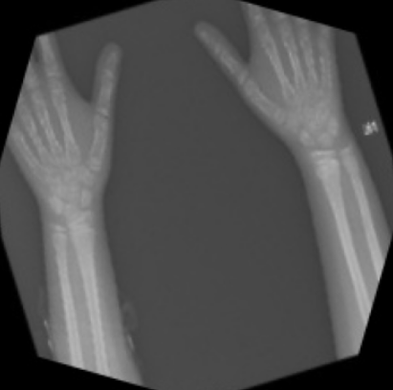

**Sample Image with Noise**

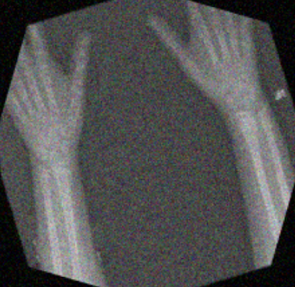

**Accuracies on original image:**

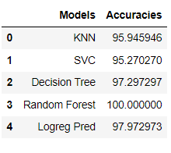

Random forest gives the best results since it uses ensemble of various classifiers.

**Accuracies on noisy images:**

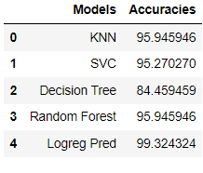

Here our accuracies of predictions have decreased for random forest because of introduction of noise.

**Accuracies on PCA transformed original image**

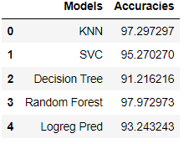

Although accuracy on PCA transformed image has somewhat decreased, but the amount of compression achieved compensates for that. We only used 40 most important features out of 150528 total features! A huge data compression without much loss on accuracies of results. Even if it is a lossy compression, we achieve good results.

**Accuracies on PCA transformed noisy image**

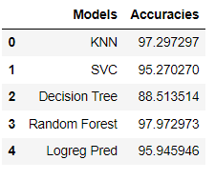

The important thing to note is that even if we use noisy images after applying PCA on it, results are comparable with if we use original image with PCA. This demonstrates the power of PCA to remove noise without much loss of information.

**References:**

[https://web.archive.org/web/20060903140351id_/http://lcv.stat.fsu.edu/research/geometrical_representations_of_faces/PAPERS/survey_zhang.pdf](https://web.archive.org/web/20060903140351id_/http:/lcv.stat.fsu.edu/research/geometrical_representations_of_faces/PAPERS/survey_zhang.pdf)

“Digital Image Processing” Rafael C. Gonzalez and Paul Wintz, Addison-Wesley Publishing Company, 1987

“Elementary Linear Algebra 5e” by Howard Anton, Publisher John Wiley & Sons Inc

<http://www.cs.otago.ac.nz/cosc453/student_tutorials/principal_components.pdf>

<https://www.jpier.org/pier/pier.php?paper=12061410>